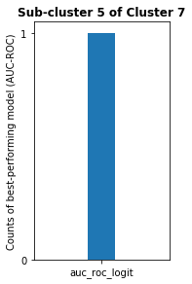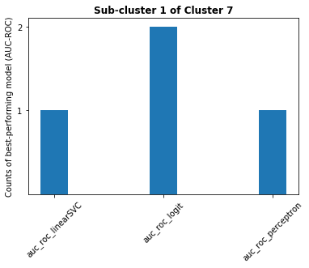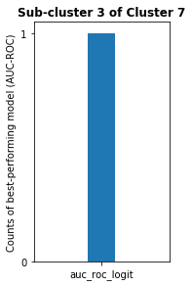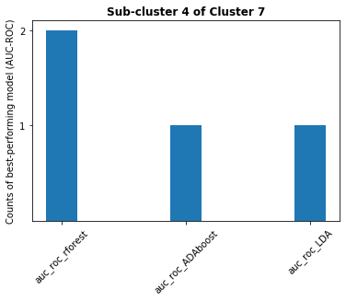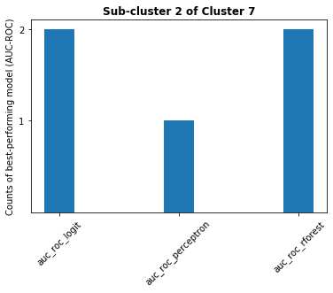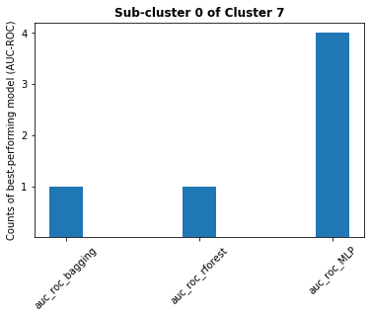

**Cluster 7**

**Sub-clusters of**

**cluster 7**

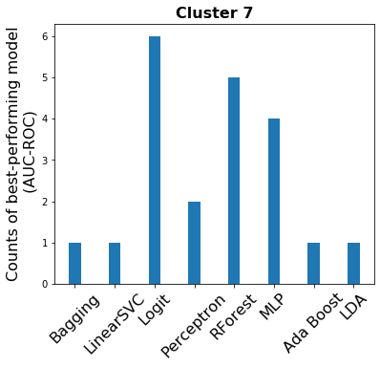

**Cluster 7:**

**21 datasets**

**Sub-clusters of cluster 7:**

**6 sub-clusters**

**…**

**…**

**Cluster 7:**

**21 datasets**

**Sub-clusters of cluster 7:**

**6 sub-clusters**